

15 July 2019

Globalisation and Heated Debates: A summary of IPYLC Day 1

Delegates of Security Council 2 are undergoing an unmoderated caucus to discuss the general agenda of the debate; the excessive brutality in law. **PHOTO: Ryarn Leck**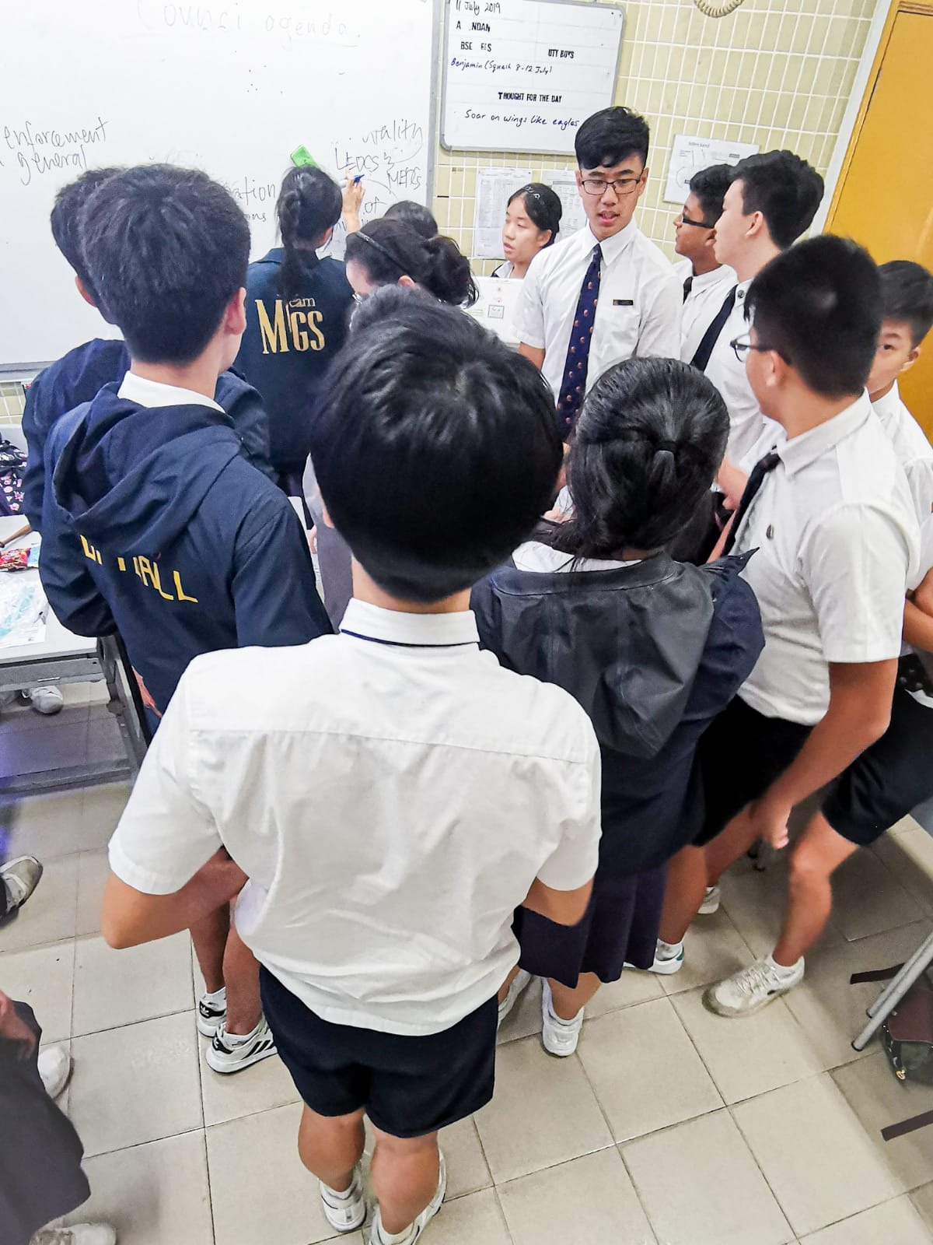

**IPYLC Day 1**

The Integrated Programme Youth Leadership Conference (IPYLC) is a programme based on Model United Nations Conferences which kicked off yesterday in Anglo-Chinese School (Independent) as part of its IP Symposium, where Year 3 IP students from both ACS(I) itself and Methodist Girls’ School are taking part in this 3-day long programme.

The Symposium started off with a keynote address by the Guest-of-Honour, Christopher Ong, the vice president and marketing director of DHL Singapore, on globalisation and its importance in the current age. He covered the significance of globalisation and its great presence in Singapore, as well as the idea of corporate stewardship in this ever-connected world.

Afterwards, the debates for each of the individual councils commenced. The topics discussed by the Economic and Social Council (ECOSOC), Security Council 2 (SC2) and General Assembly 2 (GA2) are Food Security, excessive brutality in law and the Yemeni Civil War respectively.

In SC2, the delegates were tasked with discussing their representative countries’ views on excessive brutality by law. Most of the delegates took a moderate stance on police brutality, making the general point that violence should be contained and only used in self defence while other delegates, especially those of the US and Saudi Arabia outrightly denounced it and did not support it whatsoever, claiming that it is inhumane. However, most notably, the delegates of the Democratic Republic of the Congo and Yemen, who felt that brutality was required to solve their problems. Examples by the delegate of Yemen include the raping of prisoners by prison guards to forcefully lead the prisoners to confess to their crimes, and Yemen feels that a uniform system must be established where the countries can go to each other’s aids whenever necessary. The conflict was left unresolved.

In GA2, the delegates were divided in their views on the civil war. Most nations took an unclear stance, with the delegates discussing whether to focus on the humanitarian aid or the war. The topic bounced between different solutions which were even more diverse, ranging from temporary ceasefires and humanitarian aid to direct military confrontation or mediation with the rebels though peace talks. At the end, there was no main consensus as to how to solve the issue, although many countries want to call for safe zones for the Yemeni people.

In ECOSOC, the delegates were assigned with the topic of food security, of which most nations addressed the issue at hand. Problems include the effects of climate change which led to food shortages, while the delegates also came up with resolutions to tackle this problem. Some raised include renewable energy sources, more hydroponics farms and the cutting down of public transport, by the delegates of India and Italy. Other delegates supported the above solutions to this problem with no conflict in debate whatsoever.

**Editor: Issac Lim and Ryarn Leck**